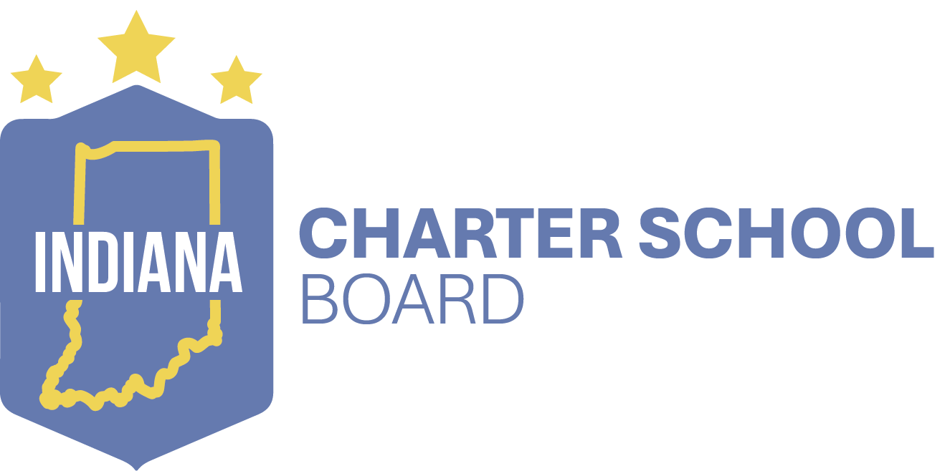
Notice of Public Hearing

Date and Time | Location | Organizer | School
November, 5, 2025  5:00 p.m.  (local time)  ICSB staff will conclude the public hearing after all attendees have spoken and it is evident no one else will be joining the session. | Higher Institute of Arts and Technology  5861 Harrison St  Merrillville, IN 46410 | Higher Institute of Arts and Technology, Inc. | Higher Institute of Arts and Technology  Merrillville, IN

All stakeholders may submit public comment via the QR Code below or through this link: https://forms.office.com/g/E8YnRU6KUc. The comment will be included with the information presented to the board. All public comments have the same consideration. The Public Comment period ends November 21, 2025 at 12:00 p.m. ET.


All public meetings of the Indiana Charter School Board are accessible to persons with disabilities. For persons who are hearing impaired or deaf and who require interpreter services for the meeting, notify Beatriz Garcia in writing at Indiana Charter School Board, 143 W. Market St, Indianapolis, Indiana 46204; by TDD at (317) 232-0570; or by telephone at (317) 232-7585. Notification must be made at least forty-eight (48) business hours in advance of the meeting. For persons who are visually impaired or blind and who require large-print or Braille copies of materials to be distributed at the meeting, please contact the person listed above at least forty-eight (48) business hours in advance of the meeting.

